Module 02
Aim : Virtualization in Cloud- Creating and running virtual machines..
Objective: To learn different types of virtualizations, Host and bare metal hypervisors and implement horizontal scalability.

Technology: XEN/ Vmwares EXSi
Hosted Virtualization on Oracle Virtual Box Hypervisor
Hosted Virtualization on KVM Hypervisor
Theory:
In computing, virtualization refers to the act of creating a virtual (rather than actual) version of something, including virtual computer hardware platforms, operating systems, storage devices, and computer network resources.

Why is virtualization useful?
The techniques and features that VirtualBox provides are useful for several scenarios:
- Running multiple operating systems simultaneously. VirtualBox allows you to run more than one operating system at a time. Since you can configure what kinds of "virtual" hardware should be presented to each such operating system, you can install an old operating system such as DOS or OS/2 even if your real computer's hardware is no longer supported by that operating system.
- Easier software installations. Software vendors can use virtual machines to ship entire software configurations. For example, installing a complete mail server solution on a real machine can be a tedious task. With VirtualBox, such a complex setup (then often called an "appliance") can be packed into a virtual machine. Installing and running a mail server becomes as easy as importing such an appliance into VirtualBox.
- Testing and disaster recovery. Once installed, a virtual machine and its virtual hard disks can be considered a "container" that can be arbitrarily frozen, woken up, copied, backed up, and transported between hosts. On top of that, with the use of another VirtualBox feature called "snapshots", one can save a particular state of a virtual machine and revert back to that state, if necessary. This way, one can freely experiment with a computing environment. If something goes wrong (e.g. after installing misbehaving software or infecting the guest with a virus), one can easily switch back to a previous snapshot and avoid the need of frequent backups and restores. Any number of snapshots can be created, allowing you to travel back and forward in virtual machine time. You can delete snapshots while a VM is running to reclaim disk space.
- Infrastructure consolidation. Virtualization can significantly reduce hardware and electricity costs. Most of the time, computers today only use a fraction of their potential power and run with low average system loads. A lot of hardware resources as well as electricity is thereby wasted. So, instead of running many such physical computers that are only partially used, one can pack many virtual machines onto a few powerful hosts and balance the loads between them.
Hypervisor
A hypervisor or virtual machine monitor (VMM) is a piece of computer software, firmware or hardware that creates and runs virtual machines. It allows multiple operating systems to share a single hardware host. Each operating system appears to have the host's processor, memory, and other resources all to itself. However, the hypervisor is actually controlling the host processor and resources, allocating what is needed to each operating system in turn and making sure that the guest operating systems (called virtual machines) cannot disrupt each other.
There are two types of hypervisors: Type 1 and Type 2.
- Type 1 hypervisor (also called a bare metal hypervisor) is installed directly on physical host server hardware just like an operating system. Type 1 hypervisors run on dedicated hardware. They require a management console and are used in data centers. Examples include Oracle OVM for SPARC, ESXi, Hyper-V and KVM.
- Type 2 hypervisors support guest virtual machines by coordinating calls for CPU, memory, disk, network and other resources through the physical host's operating system. This makes it easy for an end user to run a virtual machine on a personal computing device. Examples include VMware Fusion, Oracle Virtual Box, Oracle VM for x86, Solaris Zones, Parallels and VMware Workstation.
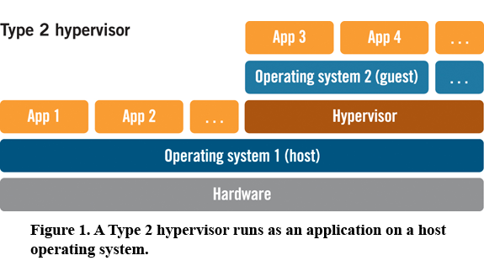
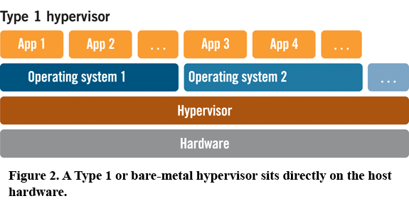
Terminology
Host operating system (host OS).
This is the operating system of the physical computer on which VirtualBox was installed. There are versions of VirtualBox for Windows, Mac OS X, Linux and Solaris hosts.

Guest operating system (guest OS).
This is the operating system that is running inside the virtual machine. Theoretically, VirtualBox can run any operating system (DOS, Windows, OS/2, FreeBSD, OpenBSD).
Virtual machine (VM).
This is the special environment that VirtualBox creates for your guest operating system while it is running. In other words, you run your guest operating system "in" a VM. Normally, a VM will be shown as a window on your computer's desktop, but depending on which of the various frontends of VirtualBox you use, it can be displayed in full screen mode or remotely on another computer.
In a more abstract way, internally, VirtualBox thinks of a VM as a set of parameters that determine its behavior. They include hardware settings as well as state information. These settings are mirrored in the VirtualBox Manager window as well as the VBoxManage command line program.
Guest Additions.
This refers to special software packages which are shipped with VirtualBox but designed to be installed inside a VM to improve performance of the guest OS and to add extra features.
Procedure :
A) Hosted Virtualization on Oracle Virtual Box Hypervisor
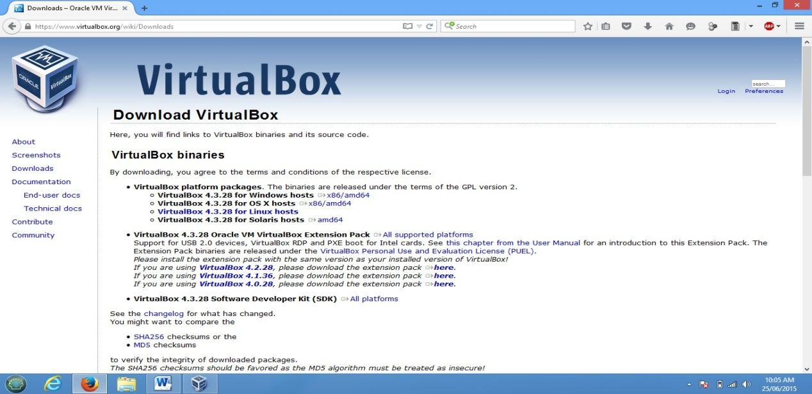
Step 1: Download Oracle Virtual box from https://www.virtualbox.org/wiki/Downloads

Step 2: Install it in Windows, Once the installation has done open it.
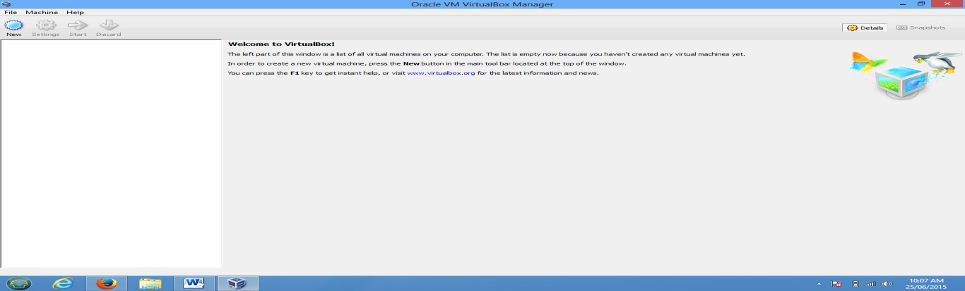
Step 3:-: Create Virtual Machine by clicking on New
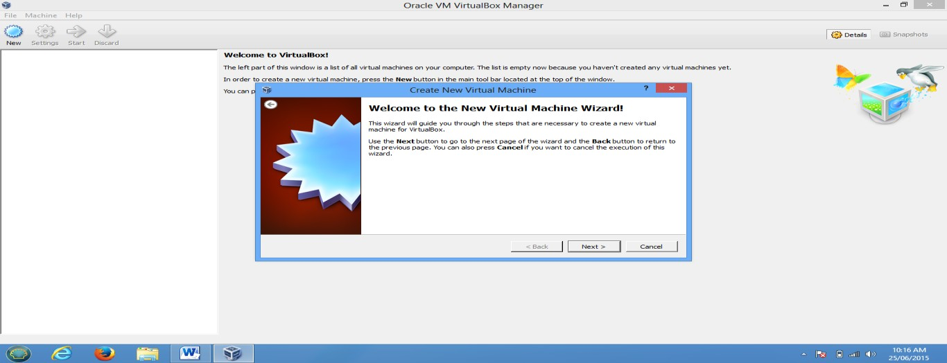
Step 4-: Specify RAM Size, HDD Size, and Network Configuration and Finish the wizard
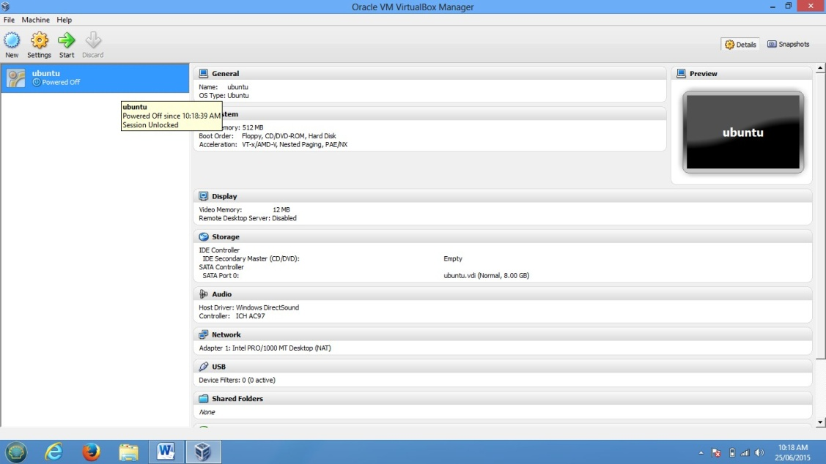

Step 5-: To Select the media for installation Click on start and browse for iso file
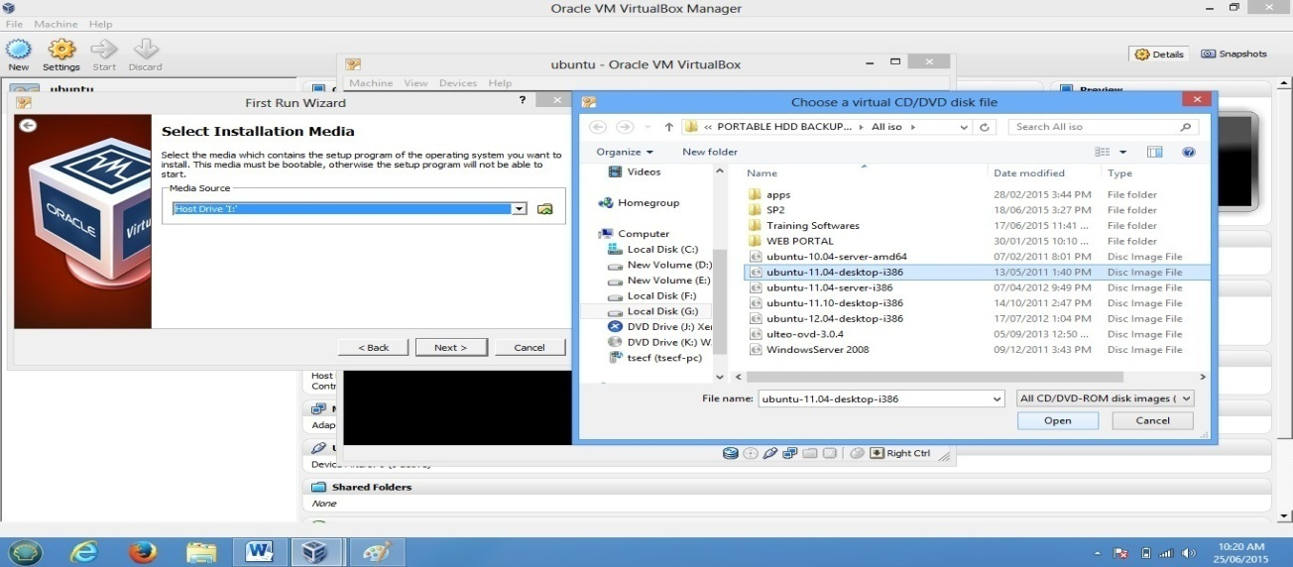
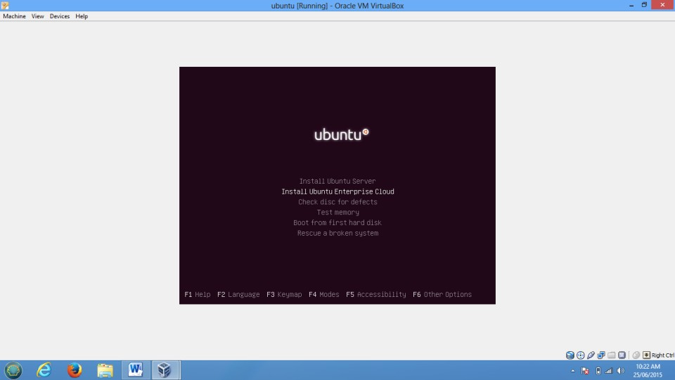
Step 6:Complete the Installation and use it.

Step 7: To Connect OS to the network change network Mode to Bridge Adaptor
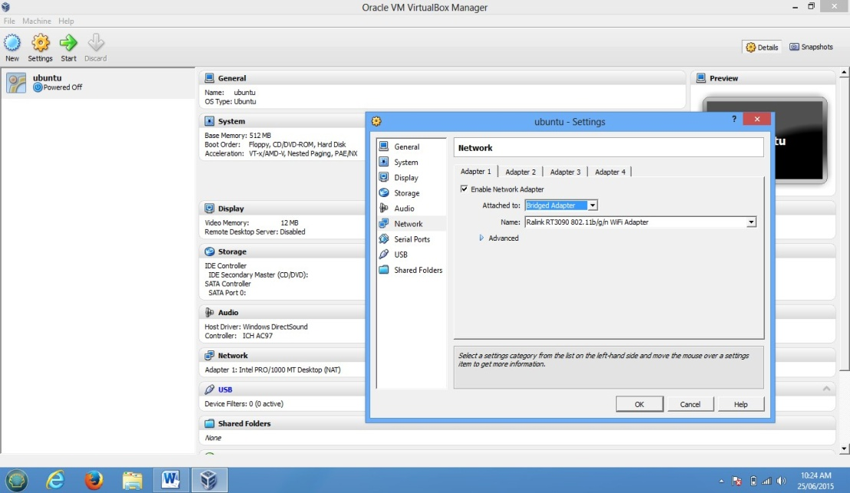
B) Hosted Virtualization on KVM Hypervisor
The Steps to Create and run Virtual machines in KVM are as follows
1) Check whether CPU has hardware virtualization support.
KVM only works if your CPU has hardware virtualization support – either Intel VT-x or AMD-V. To determine whether your CPU includes these features, run the following command:
#sudo grep -c "svm\|vmx" /proc/cpuinfo
A 0 indicates that your CPU doesn’t support hardware virtualization, while a 1 or more indicates that it does.
2) Install KVM and supporting packages.
Virt-Manager is a graphical application for managing your virtual machines.you can use the kvm command directly, but libvirt and Virt-Manager simplify the process.
#sudo apt-get install qemu-kvm libvirt-bin bridge-utils virt-manager
3) Create User.
Only the root user and users in the libvirtd group have permission to use KVM virtual machines. Run the following command to add your user account to the libvirtd group:
#sudo adduser sakec
#sudo adduser sakec libvirtd
After running this command, log out and log back in as sakec
4) Check whether everything is working correctly.
Run following command after logging back in as sakec and you should see an empty list of virtual machines. This indicates that everything is working correctly.
#virsh -c qemu:///system list
5) Open Virtual Machine Manager application and Create Virtual Machine
#virt-manager
6) Create and run Virtual Machines
PART II
Creating and running virtual machines on Bare-Metal Hypervisor Xen Server.

Step 1: Install Xen Server
Step i-: Insert Bootable Xen Server CD into CDROM and Make first boot device as a CDROM from BIOS
Step ii-: press F2 to see the advanced options, otherwise press Enter to start installation
Step iii -: Select Keyboard Layout
Step iv -:Press Enter to load Device Drivers
Step v -:Press Enter to Accept End user license Agreement
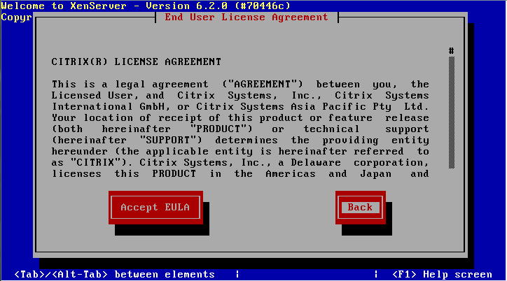

Step vi -:Select Appropriate disk on which you want to install Xen server
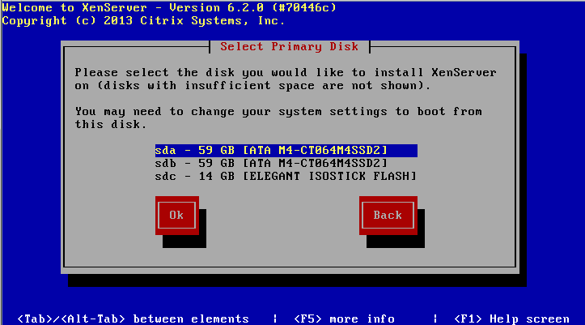
Step vii -:Select Appropriate installation Media (LOCAL Media)
Step viii -:Select Additional Packages for installation
Step ix-: Specify Root password
Step x -: Specify IP Address to a Xen Server
Step xi-:Select Time Zone
Step xii-:Specify NTP Servers address or use manual time entry then start installation.
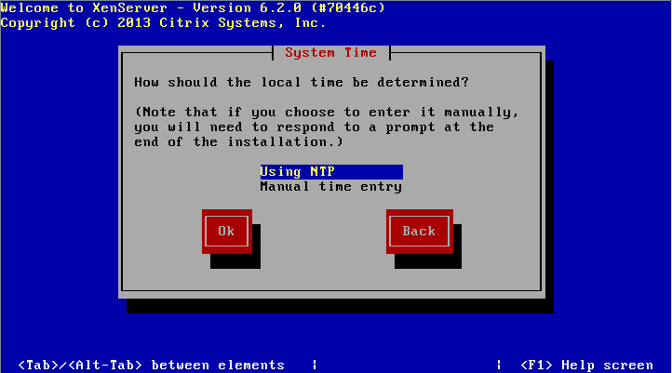
Once installation is done you will see the final screen shown below.
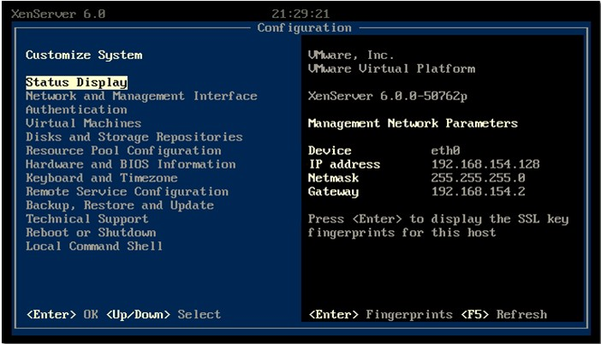
Xen Server Final Screenshot
Step 2:Connect Xen Server to Xen Center
Firstly, download the xen center a management utily from xen server by opening the xen severs IP address as a URL on browser. Once Xen center is downloaded, install it.Open Xen center from start menu of Windows.
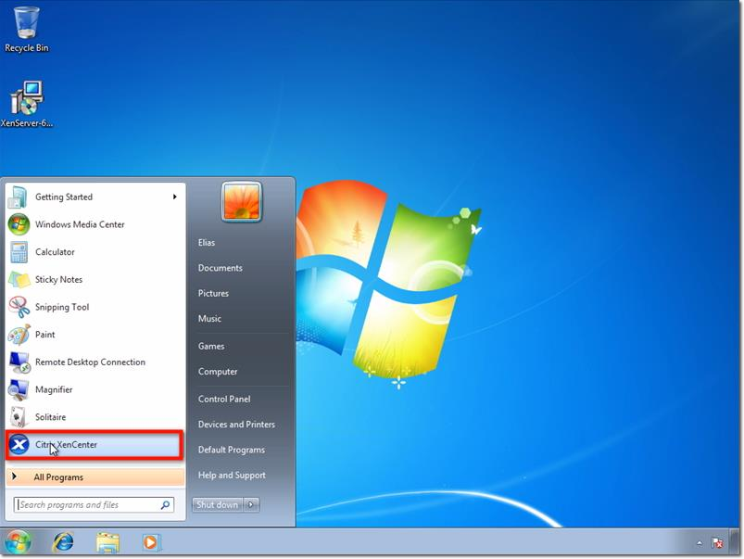
Here’s how XenCenter looks like (see screenshot below) before any hosts, resource pools, and so on, are added to it. To connect to the XenServer host you configured earlier, click Add a server.
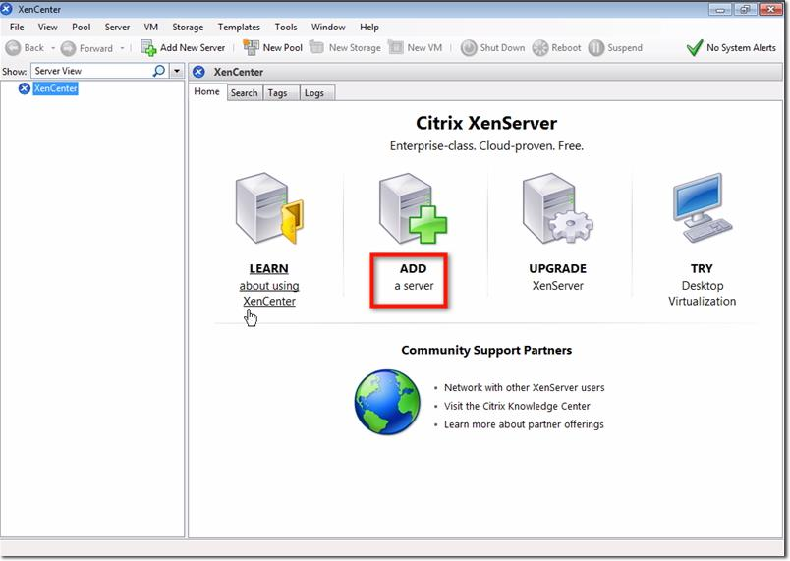
Enter the IP address I asked you to take note of earlier. Also enter the password you assigned for your root account. Click Add.
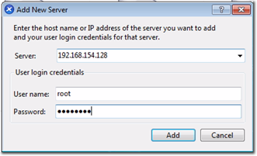

One of the first things you want to make sure as you’re adding a new XenServer to XenCenter is to save and restore the server connection state on startup. Check the box that will do just that.
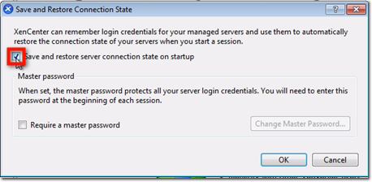
Once you do that, you will be allowed to configure a master password for all the XenServers you’ll be associating with this XenCenter. Click the Require a master password checkbox if that’s what you want to do, and then enter your desired master password in the fields provided.
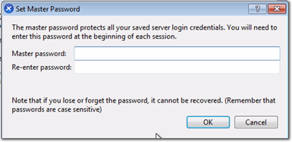
After you click OK, you’ll be brought back to the main screen, where you’ll see your XenServer already added to XenCenter.
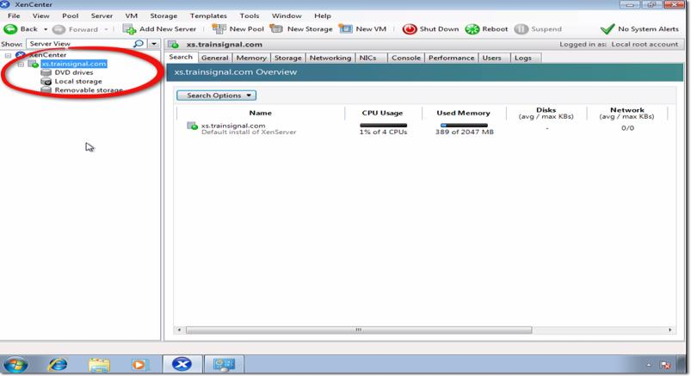

Step-:3 Create Storage Repository and Installing VM
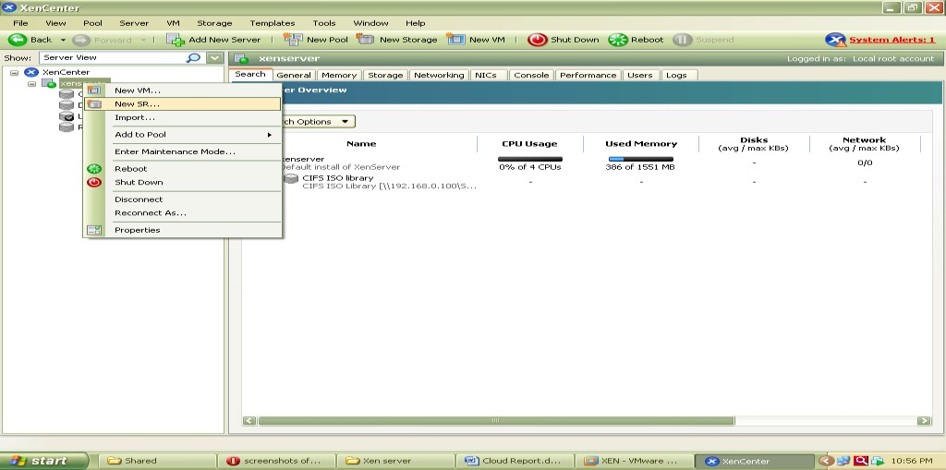
Now Before Creating VM we have to Create Storage Repository first which is nothing but shared directory on Xen Center which holds all iso files and which is required to install Operating system on Xen Server its steps are as follows.Right click on Xenserver icon on xen center and click on New SR

Now Select Windows CIFS library
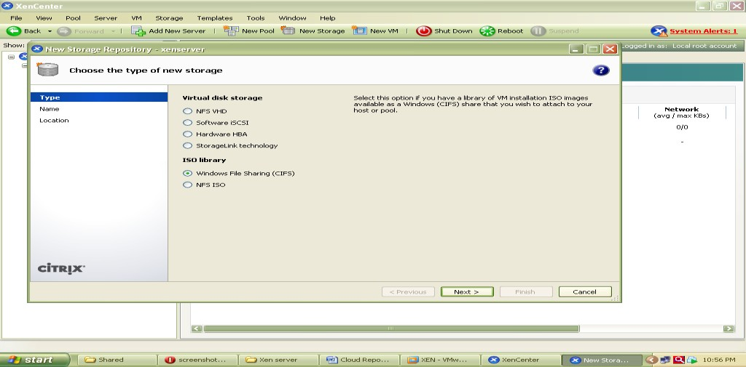
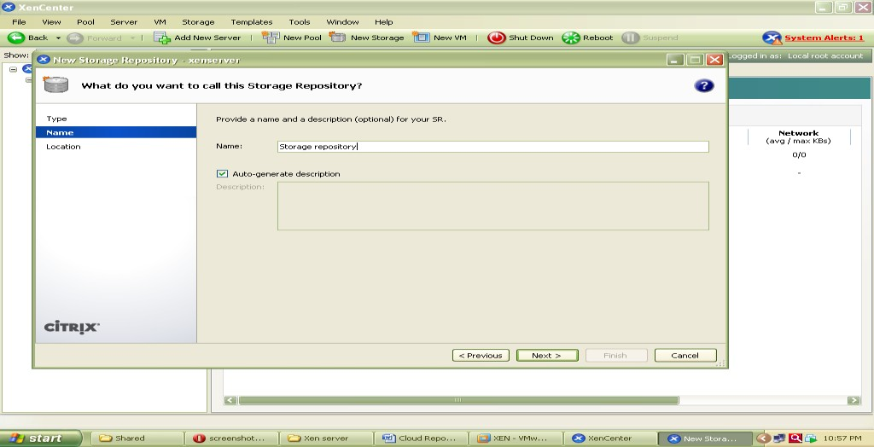
Specify Storage Repository Name
Now specify path of shared folder at client side which holds all iso files of os or VM which we are going to install on Xen Server.
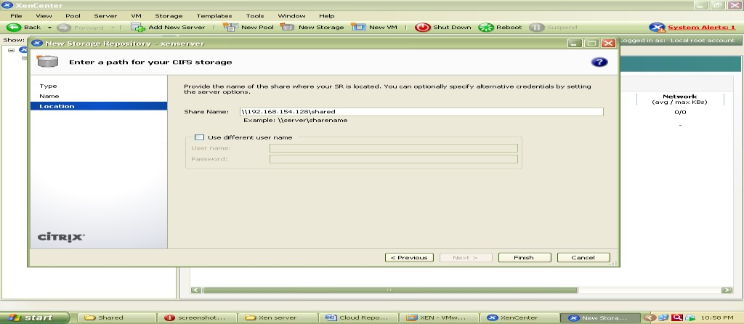

At the end Click on finish to create SR.
To check all iso files click on CIFS library and select storage this will show you all iso files.

Installation of UBUNTU Server on Xen Server
Step 1 -: Right click on Xenserver icon on xen center and select New VM

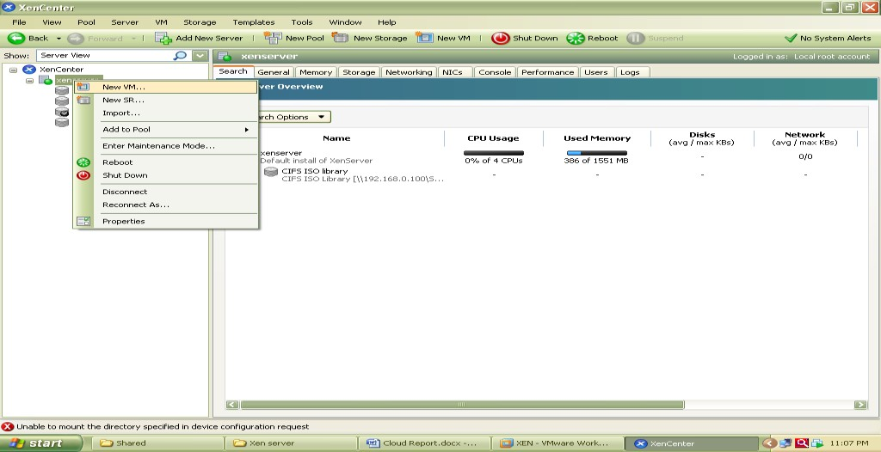
Now select an Operating System to be install here select Ubuntu Lucid Lynx and click on next
Now specify Instance Name as ubuntu server

Select iso file of Ubuntu server 10.10 to be install
Now select hardware for vm i.e. no. of cpu’s and memory
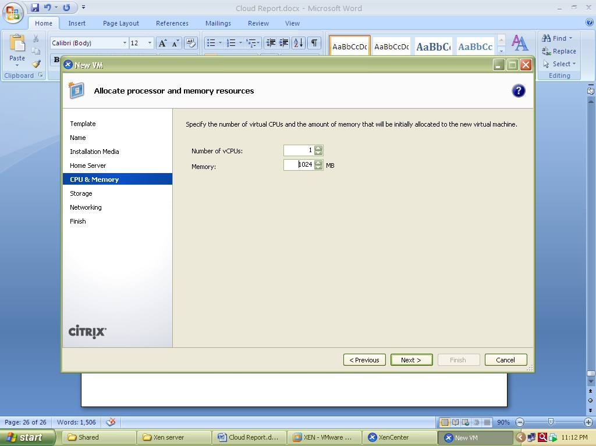
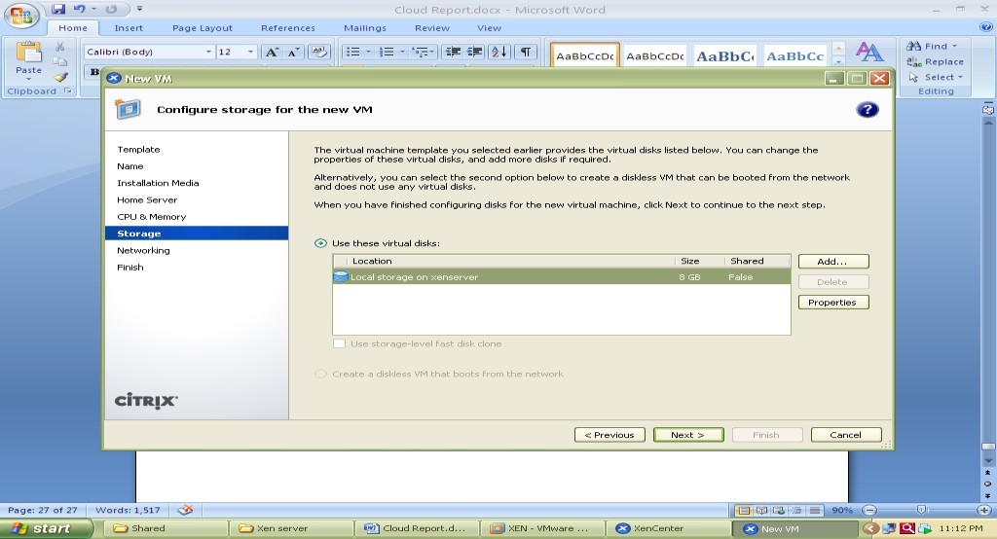
Select local storage

Select network

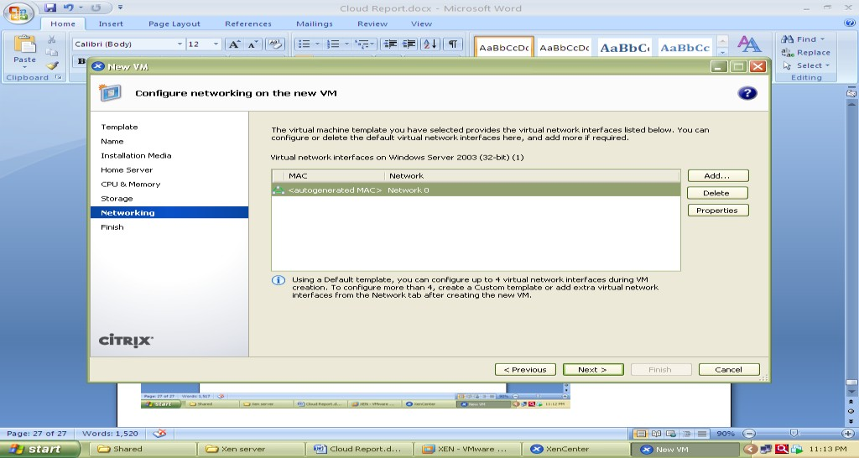

And click on finish
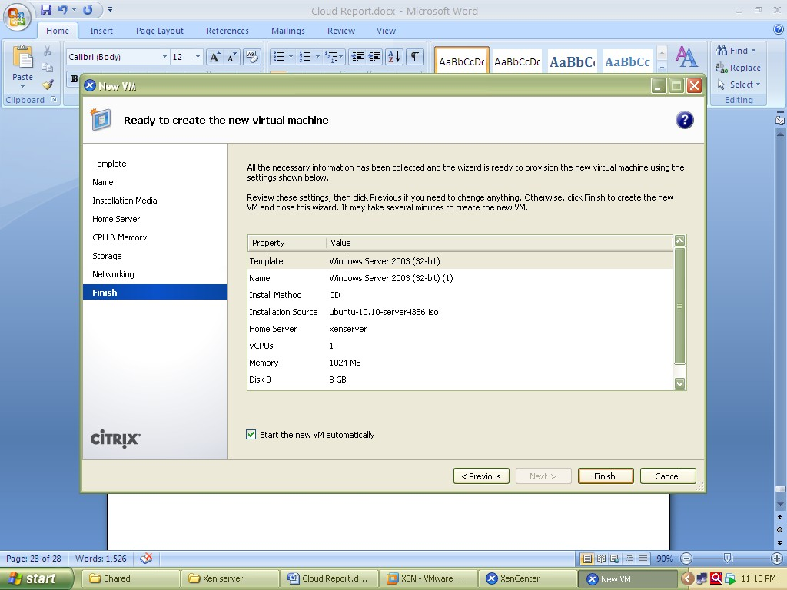

Now go to Console tab to install ubuntu and follow installation Steps.

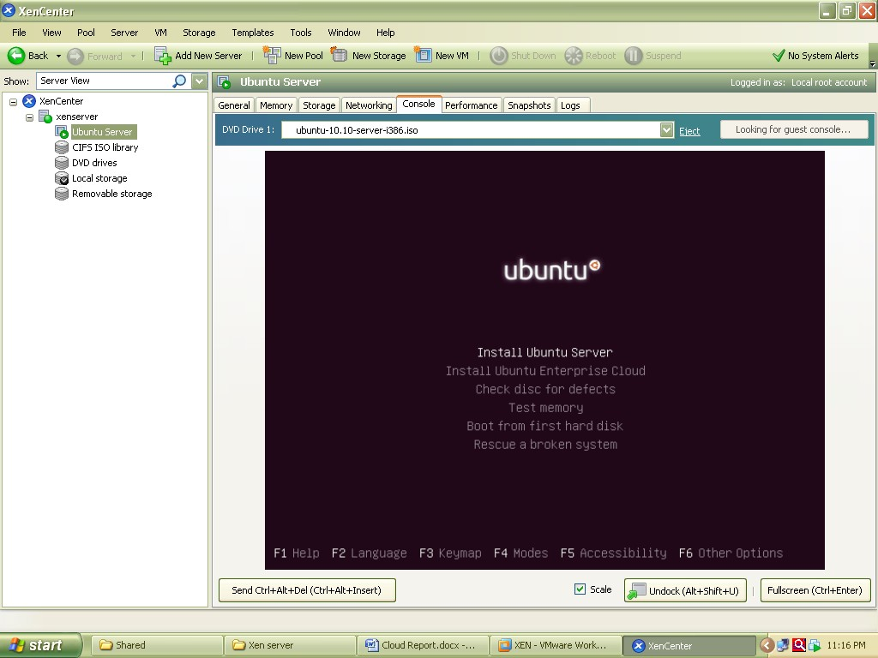

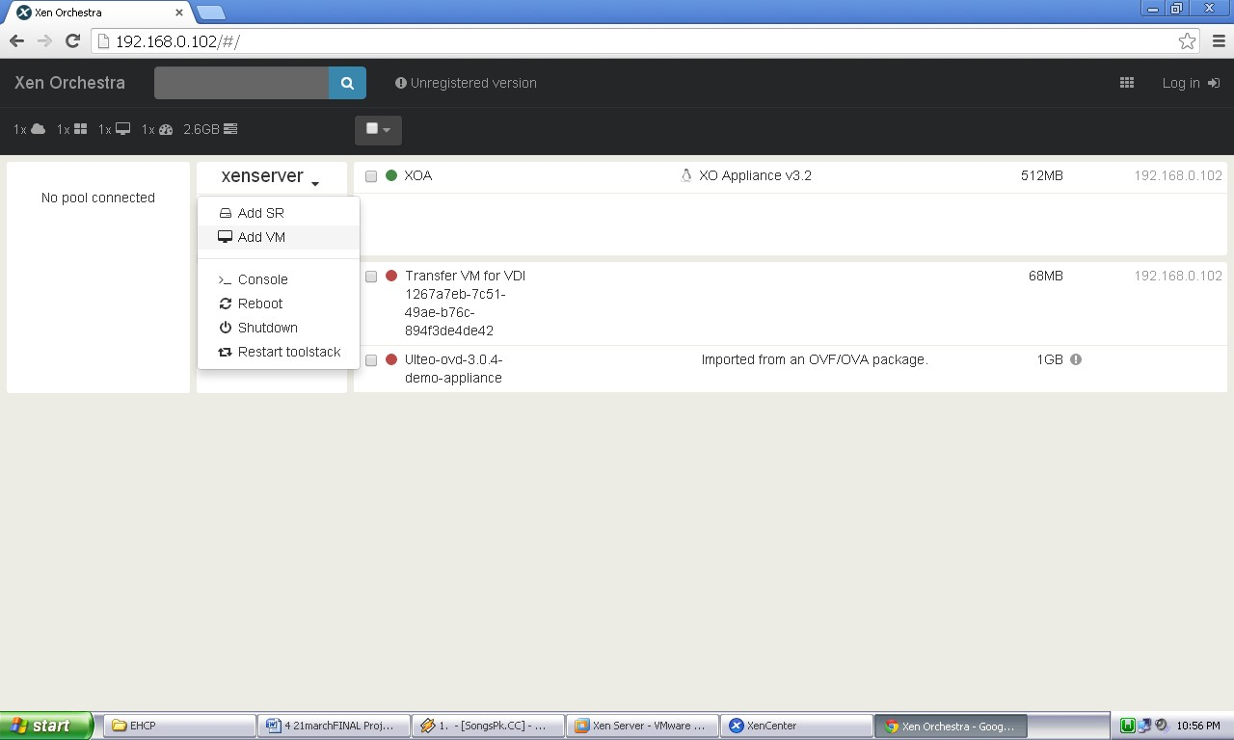
The Xen orchestra provides web based functionality of Xen Center.it provides access to all the VMs with their lifecycle management which are installed over Xen Server shown in figure

Xen Orchestra (XOA) Portal
The Windows XP image running on Xen Orchestra over Google chrome web browser is shown in following screenshot
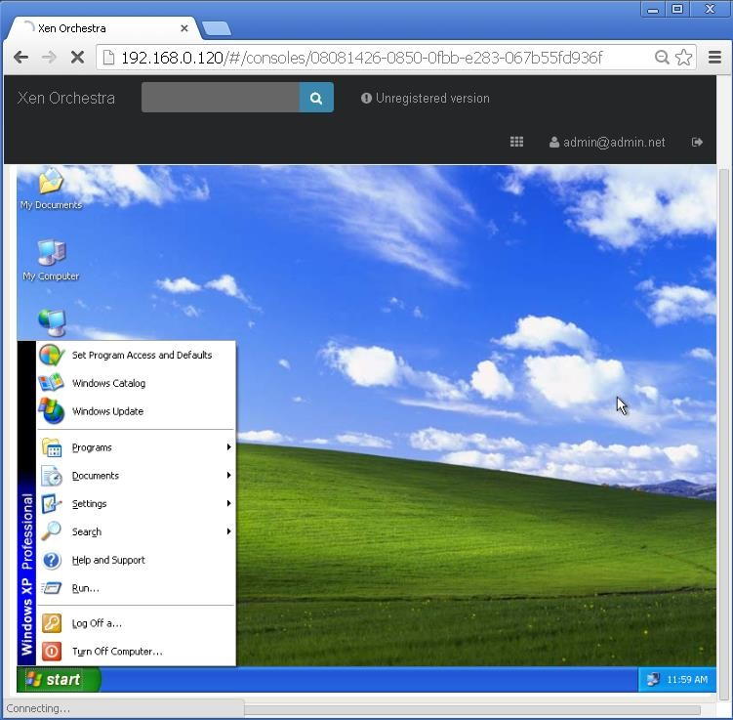
Windows XP running on Xen orchestra (XOA)
CONCLUSION:
Type 1 hypervisor (also called a bare metal hypervisor) is installed directly on physical host server hardware just like an operating system. Type 1 hypervisors run on dedicated hardware. They require a management console and are used in data centers. Examples include Oracle OVM for SPARC, ESXi, Hyper-V and KVM. Type 2 hypervisors support guest virtual machines by coordinating calls for CPU, memory, disk, network and other resources through the physical host's operating system. This makes it easy for an end user to run a virtual machine on a personal computing device. Examples include VMware Fusion, Oracle Virtual Box etc.

Program  Execution/  formation/  correction/  ethical practices  (07) | Documentation  (02) | Punctuality  (01) | Viva Answer  (05) | Experiment  Marks (15) | Teacher Signature with date

